URL shortening functionality – Tests

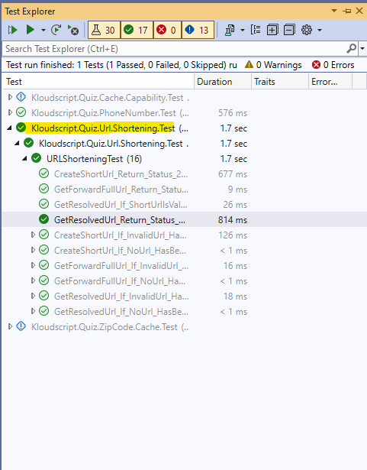

URL shortening functionality – Code Coverage

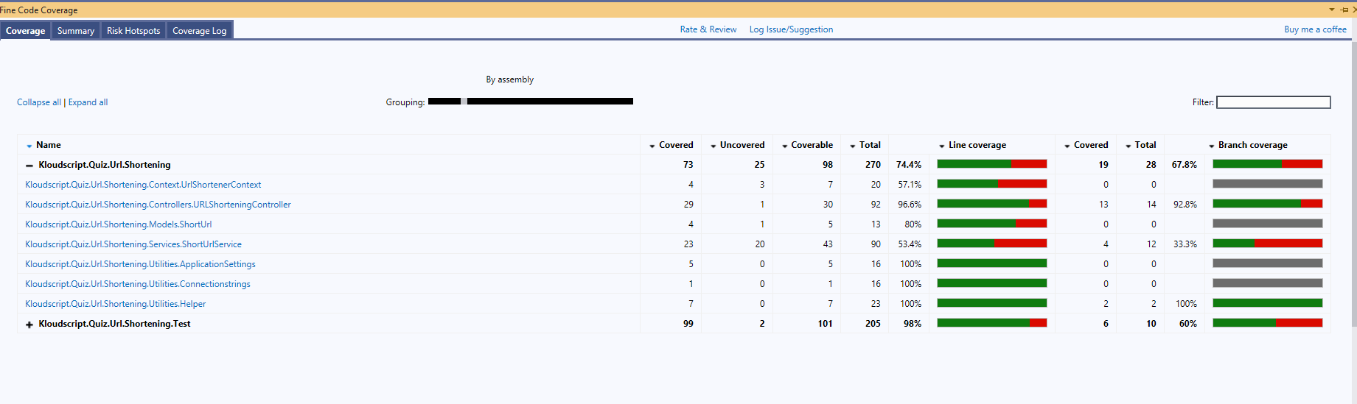

Memory Cache Capability functionality – Tests

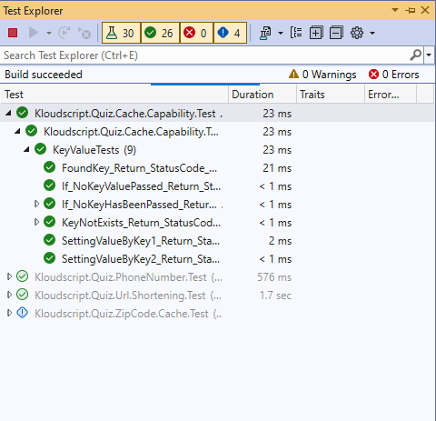

Memory Cache Capability functionality – Code Coverage

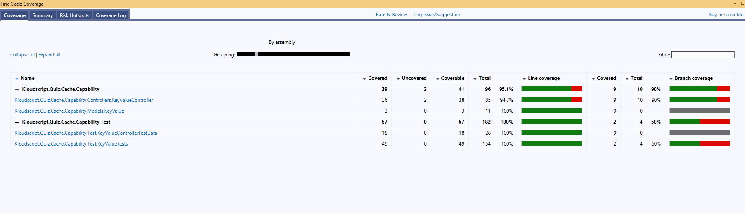

Zip Code Cache Proxy functionality – Tests

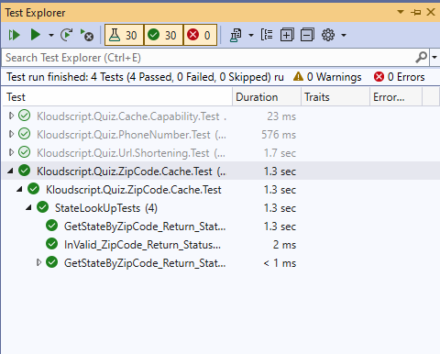

Zip Code Cache Proxy functionality – Code Coverage

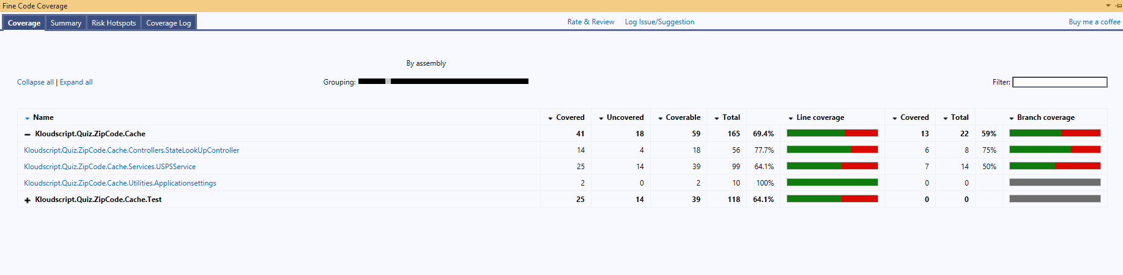

PhoneNumbers-8-digits.csv functionality – Tests

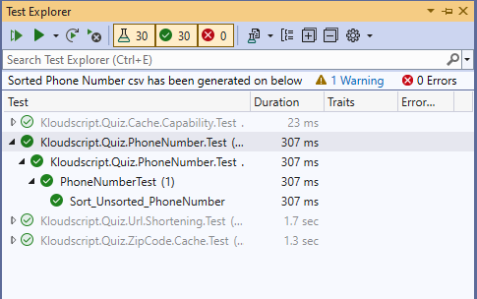

PhoneNumbers-8-digits.csv functionality – Code Coverage

